**STATISTICS**

**ASSIGNMENT-6**

**EXERCISE 1.**

Create a binomial cumulative distribution table for *n=10* using Python *scipy.stats*. You should get something like this:

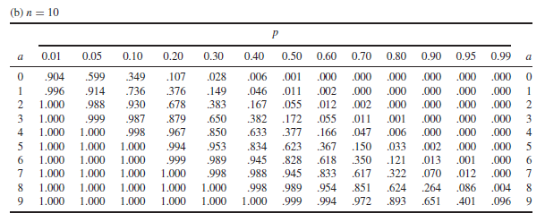

**EXERCISE 2.**

Answer the following questions by looking at the distribution table or coding with Python.

1. A salesperson has found that the probability of a sale on a single contact is approximately .3. If the salesperson contacts 10 prospects, what is the approximate probability of making at least one sale? = 0.1210
2. Ten coins are tossed simultaneously. Find the probability of getting  
   (i) at least seven heads = 0.1718  
   (ii) exactly seven heads = 0.1171  
   (iii)at most seven heads = 0.9443

**EXERCISE 3.**

Answer the following questions by looking at the distribution table or coding with Python.

1. A type of tree has seedlings dispersed in a large area with a mean density of five seedlings per square yard. What is the probability that none of ten randomly selected one-square yard regions have seedlings? 0.0067
2. Let Y denote a random variable that has a Poisson distribution with mean *λ = 2*. Find  
   (i) *P(Y = 4) = 0.0902*(ii) *P(Y ≥ 4) = 0.1428*(iii)*P(Y < 4) = 0.7217  
   (iv)P(Y ≥ 4 | Y ≥ 2 ) = 0.5413*

**EXERCISE 4.**

Consider binomial experiment for *n = 20*, *p = .05*.

1. Calculate the binomial probabilities for *Y = 0, 1, 2, 3, and 4*.

binomial probabilities for Y = 0 : 0.3584859224085422

binomial probabilities for Y = 1 : 0.3773536025353075

binomial probabilities for Y = 2 : 0.18867680126765365

binomial probabilities for Y = 3 : 0.05958214776873269

binomial probabilities for Y = 4 : 0.013327585685111255

1. Calculate the same probabilities by using the Poisson approximation with *λ = np*. Compare.

Lamda = 20 X 0.05 = 1

Poission probabilities for Y = 0 : 0.36787944117144233

Poission probabilities for Y = 1 : 0.36787944117144233

Poission probabilities for Y = 2 : 0.18393972058572114

Poission probabilities for Y = 3 : 0.06131324019524039

Poission probabilities for Y = 4 : 0.015328310048810101